Meta: Master LinkedIn searches: from basics to Boolean. Learn advanced filters & private modes to find ideal connections. Optimize your networking with pro tips.

Keywords: [LinkedIn Search](https://docs.google.com/spreadsheets/d/1-Z0Nr7boI47WA-od-iftM-MnikAicYUvCpx0qgi7rD4/edit?gid=0#gid=0)

Images and alt texts: [linkedin search](https://drive.google.com/drive/folders/1_fxLJashDez5BbCCX40NF5ZwEquxfqKi?usp=sharing)

# LinkedIn Search Hacks: Use Private Mode + Overcome Limits

**LinkedIn, as of today, has over 1 billion users** 🤯

I’ll let that sink in.

With so many people on the platform, you can bet the opportunities are going to be as big as the challenges.

On one hand, LinkedIn is **teeming with potential customers** for your business.

On the other hand, if you don’t know **how to use LinkedIn search properly** you’ll never be able to find them.

That’s quite a problem, no?

Adding to that is the LinkedIn search limit and

The risk of people getting to know you’ve been secretly searching for them. 😶‍🌫️



But hey, your 3rd grade class teacher was right.

When there’s a will, there’s a way.

In this blog, we’re going to figure out how to

💥Bypass LinkedIn search limits

💥Search on LinkedIn privately

💥Do a quick Boolean search to get super accurate results,

💥Discuss outreach strategies to get your dream customers’ attention, and so much more!

Can’t wait to begin?

Awesome, here’s the first topic:

## **How do I search for someone on LinkedIn?**

The most basic way to perform a LinkedIn search is by **using the search bar on the LinkedIn home screen.**

Just type the name in the search box. It's that easy!

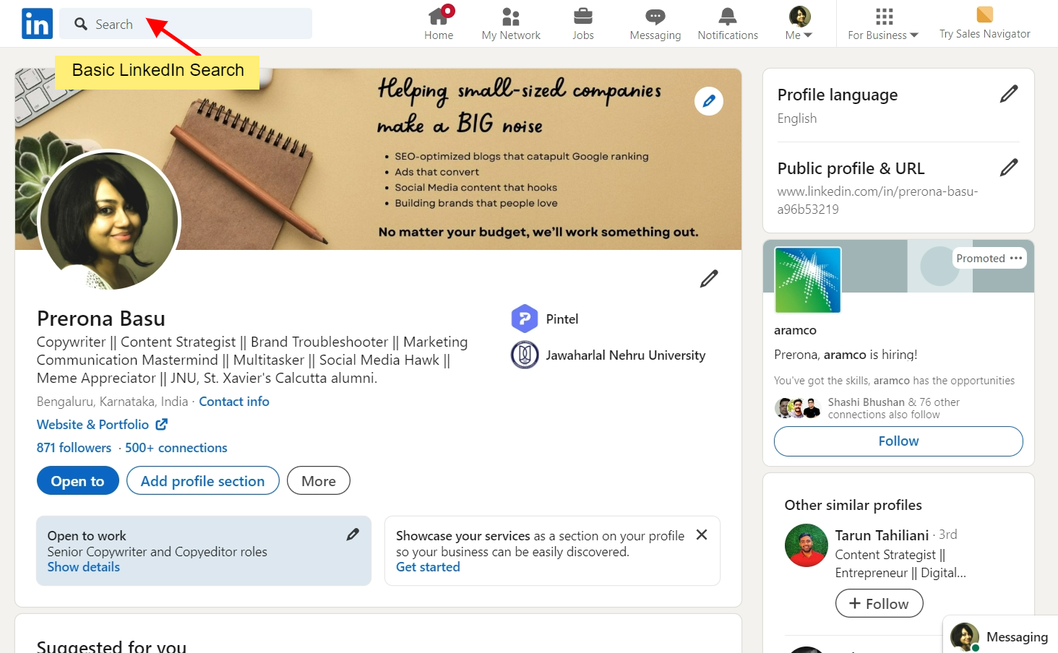

**But** what if you want to search for **people from a particular industry** or a **specific position**?

Here’s how you’re going to do it.

If, say, you are looking for a marketing manager, type ‘marketing manager’ in the search box.

Then click on ‘See all people results’ and you’ll get an expanded list.

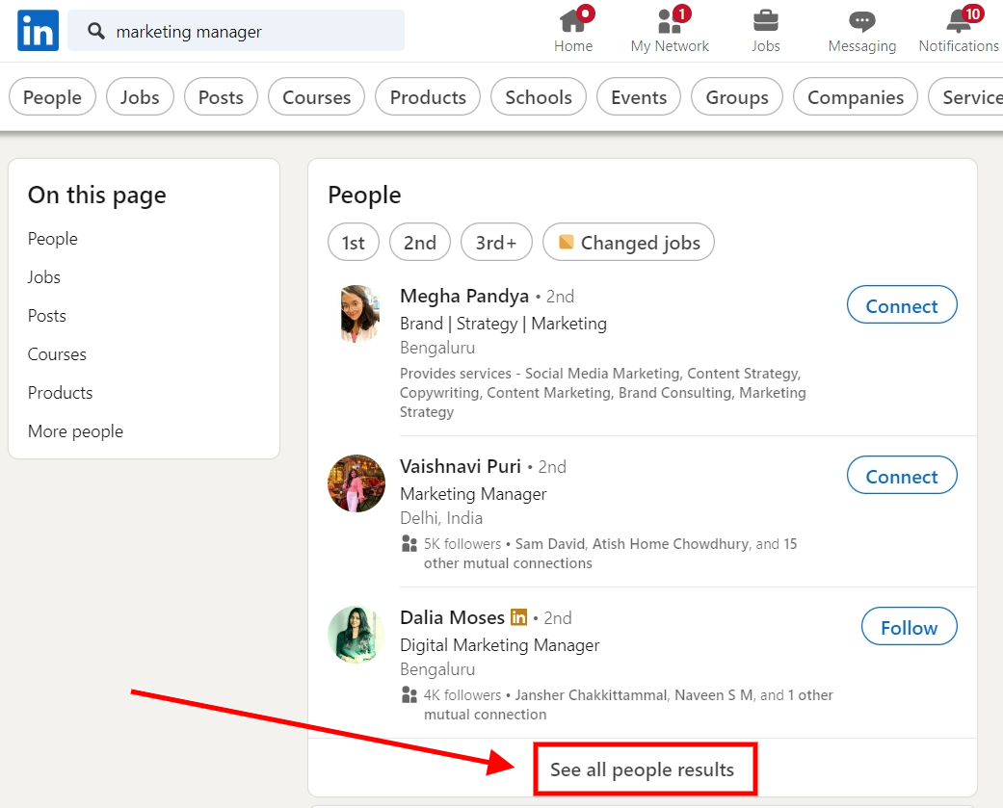

You can even search for a company or agency using a simple LinkedIn search.

But what if you’re looking for someone/something specific?

In that case we’ll need to figure out

## **What is LinkedIn Advanced Search?**

When you search for someone on LinkedIn, you’ll find a “**People**” button on the far right.

Click on it and then click the “**All filters**” button on the far left.

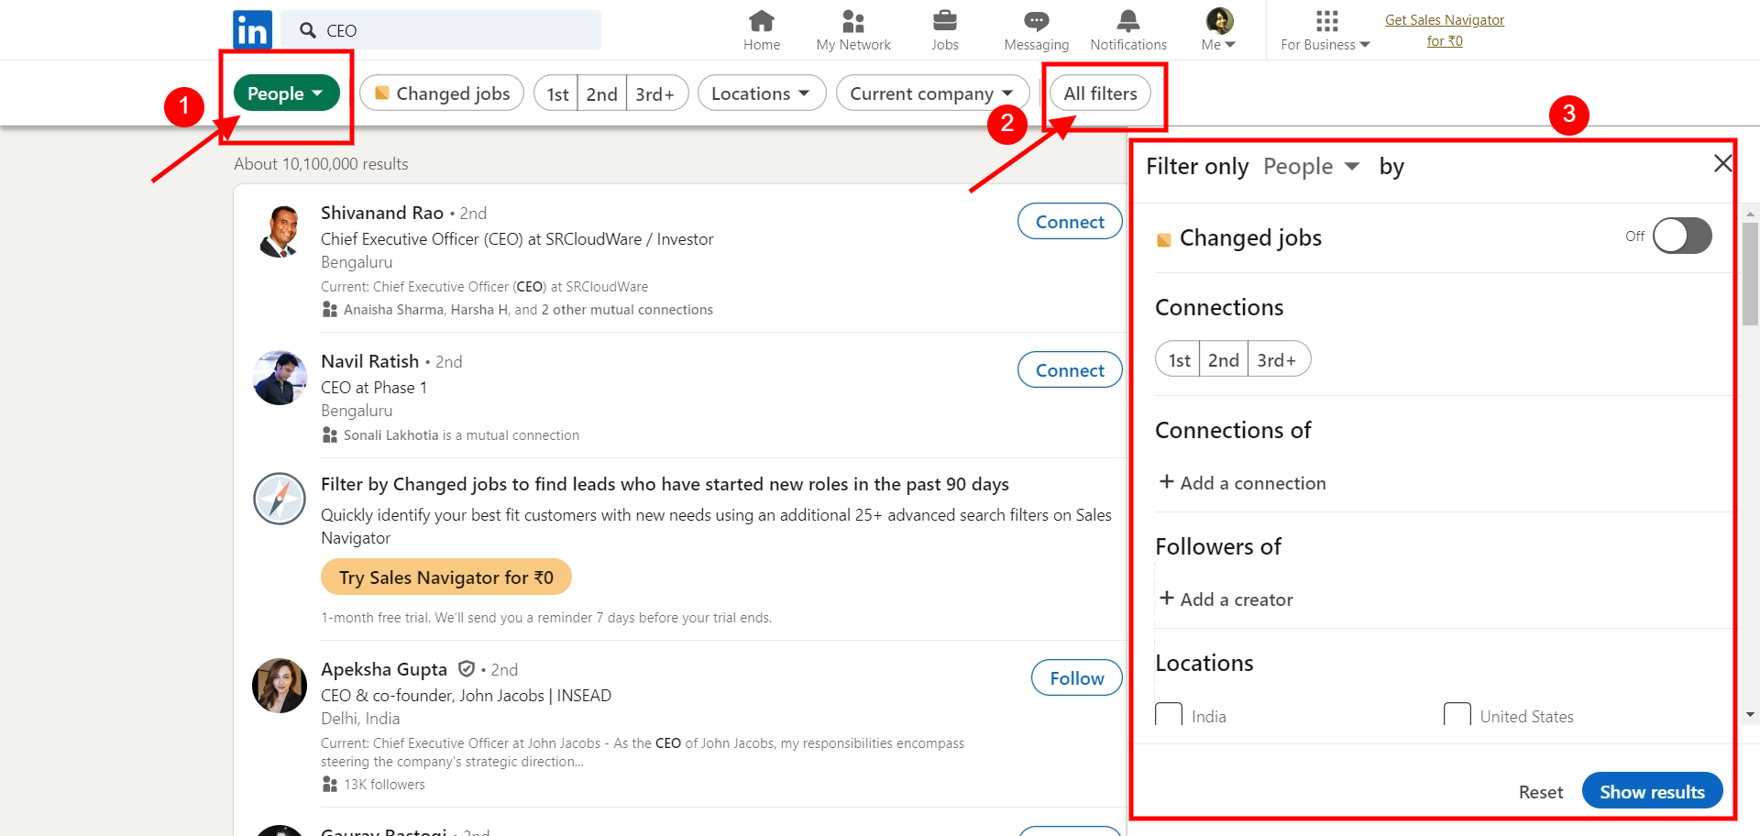

When you click on it you’ll be able to **pick from different categories to refine your search further.**



Now moving on to the next search option which gives you an even sharper and more targeted result.

## **How to Boolean Search on LinkedIn?**

## [How to use LinkedIn Boolean Search to identify your dream clients (Secret ChatGPT prompt revealed)](https://www.youtube.com/watch?v=LKj-mNR2y9o)

## [Boolean search](https://www.linkedin.com/help/linkedin/answer/a524335), **also known as LinkedIn X-Ray search lets you find specific people, jobs, or companies with the help of “operators”**.

Now what are “operators”?

Operators are words or characters that help refine, sort or do away with irrelevant keywords from your searches.

These are the **5 main operators** **you can use on LinkedIn**

1. Quotation Marks [ “ ”]
2. NOT
3. OR
4. AND
5. Parentheses [ () ]

Here are a few examples to show you how to use it.

### **Quotation marks “ ”**

Use this when you want to be **super specific** about what **results** you want from LinkedIn.

***For example:***

Say, you want to search for Chief Financial Officers.

If you do a regular search without quotes then you might find people who are into finance, who are officers, and who are the chief of some other title they may hold.

Not necessarily the people you were looking for.

This can be fixed if you search “Chief Financial Officers” - with quotation marks that is.

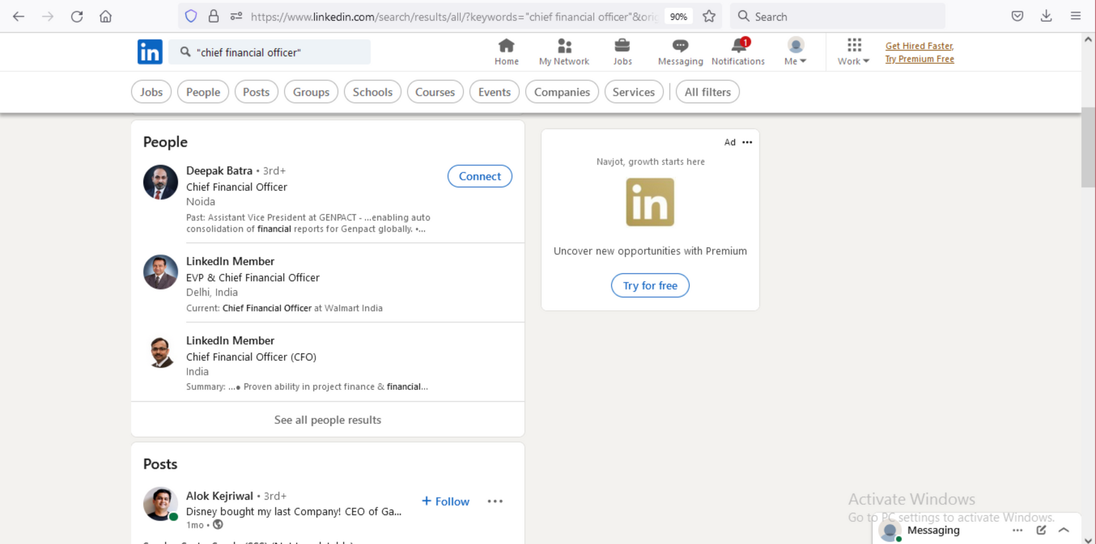*source: LinkedIn*

This makes sure your searches are exactly what you want and not some weird half-half.

### **NOT Searches**

If you want to **keep something away from the result** then just type NOT to exclude it from the search.

***For example-*** “Manager NOT designer”.

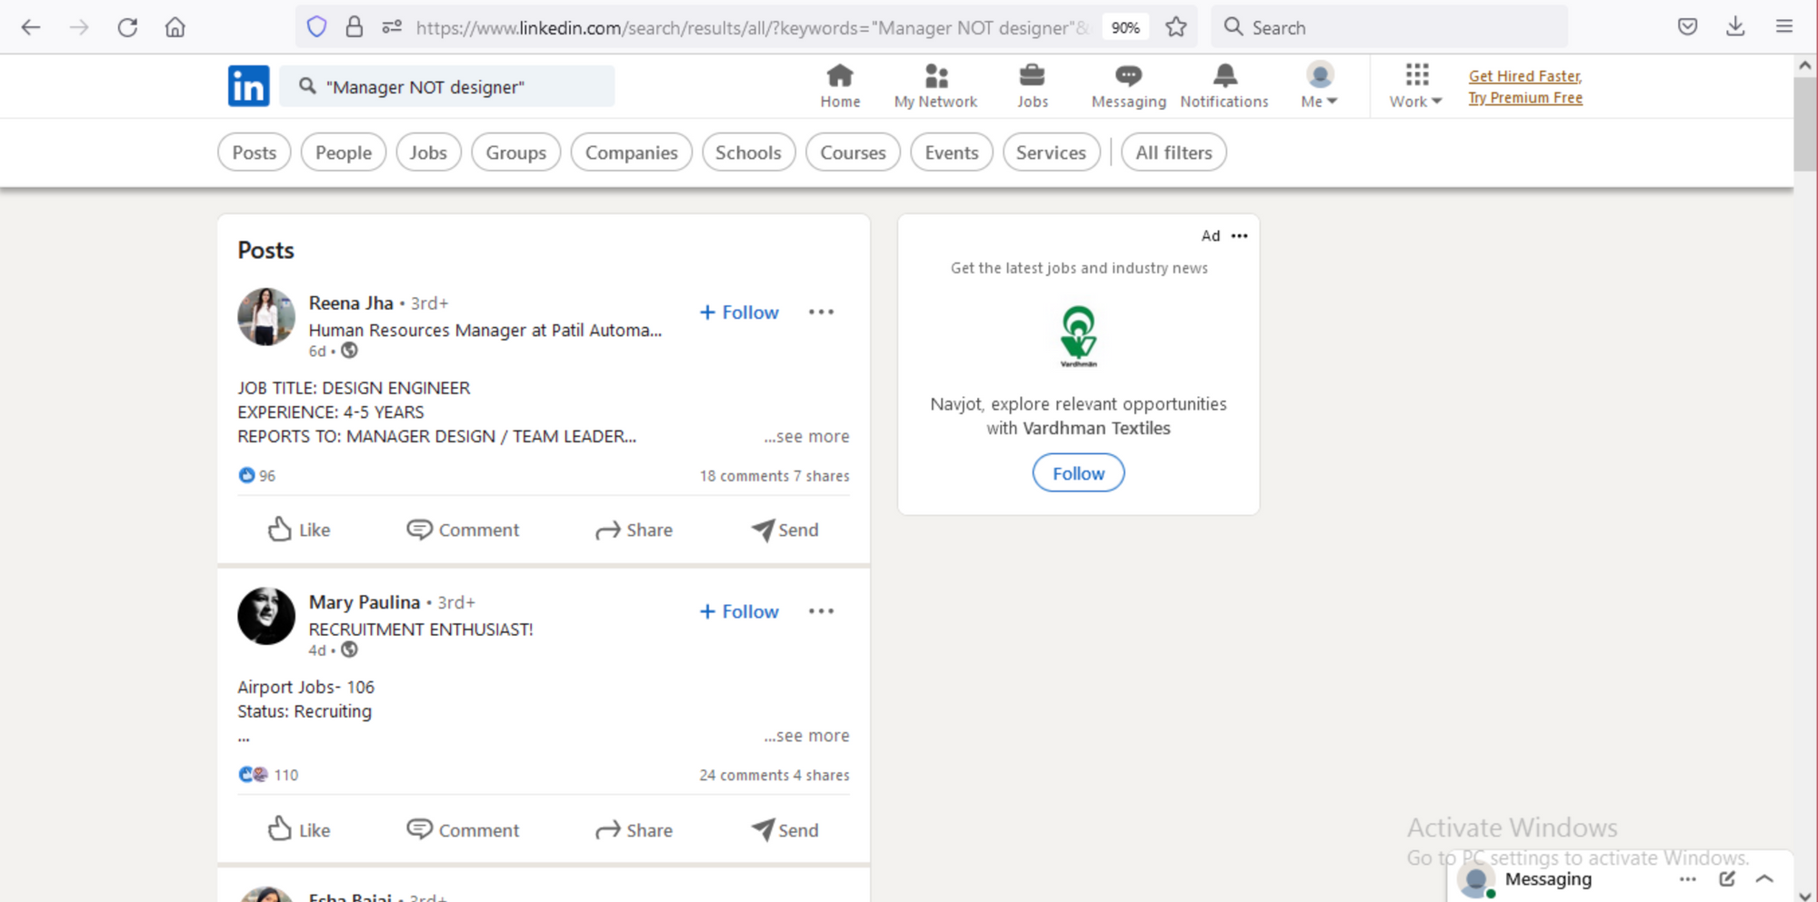*Source: LinkedIn*

This gives you the search results for managers and removes any instance of a sneaky designer.

### **OR Searches**

This can be used to **cast a wider net to your search.**

***Like:*** “Product Development OR Marketing”.

This gives results for Product Dev or Marketing individually and also results that fit both.

### **AND Searches**

Use AND (in caps) when you want to **be more specific about what you want.**

This can be used if a person is looking for all items in a list. Want to find someone who's **both** a CFO and a CA?

Search this way:  
”CFO AND CA”

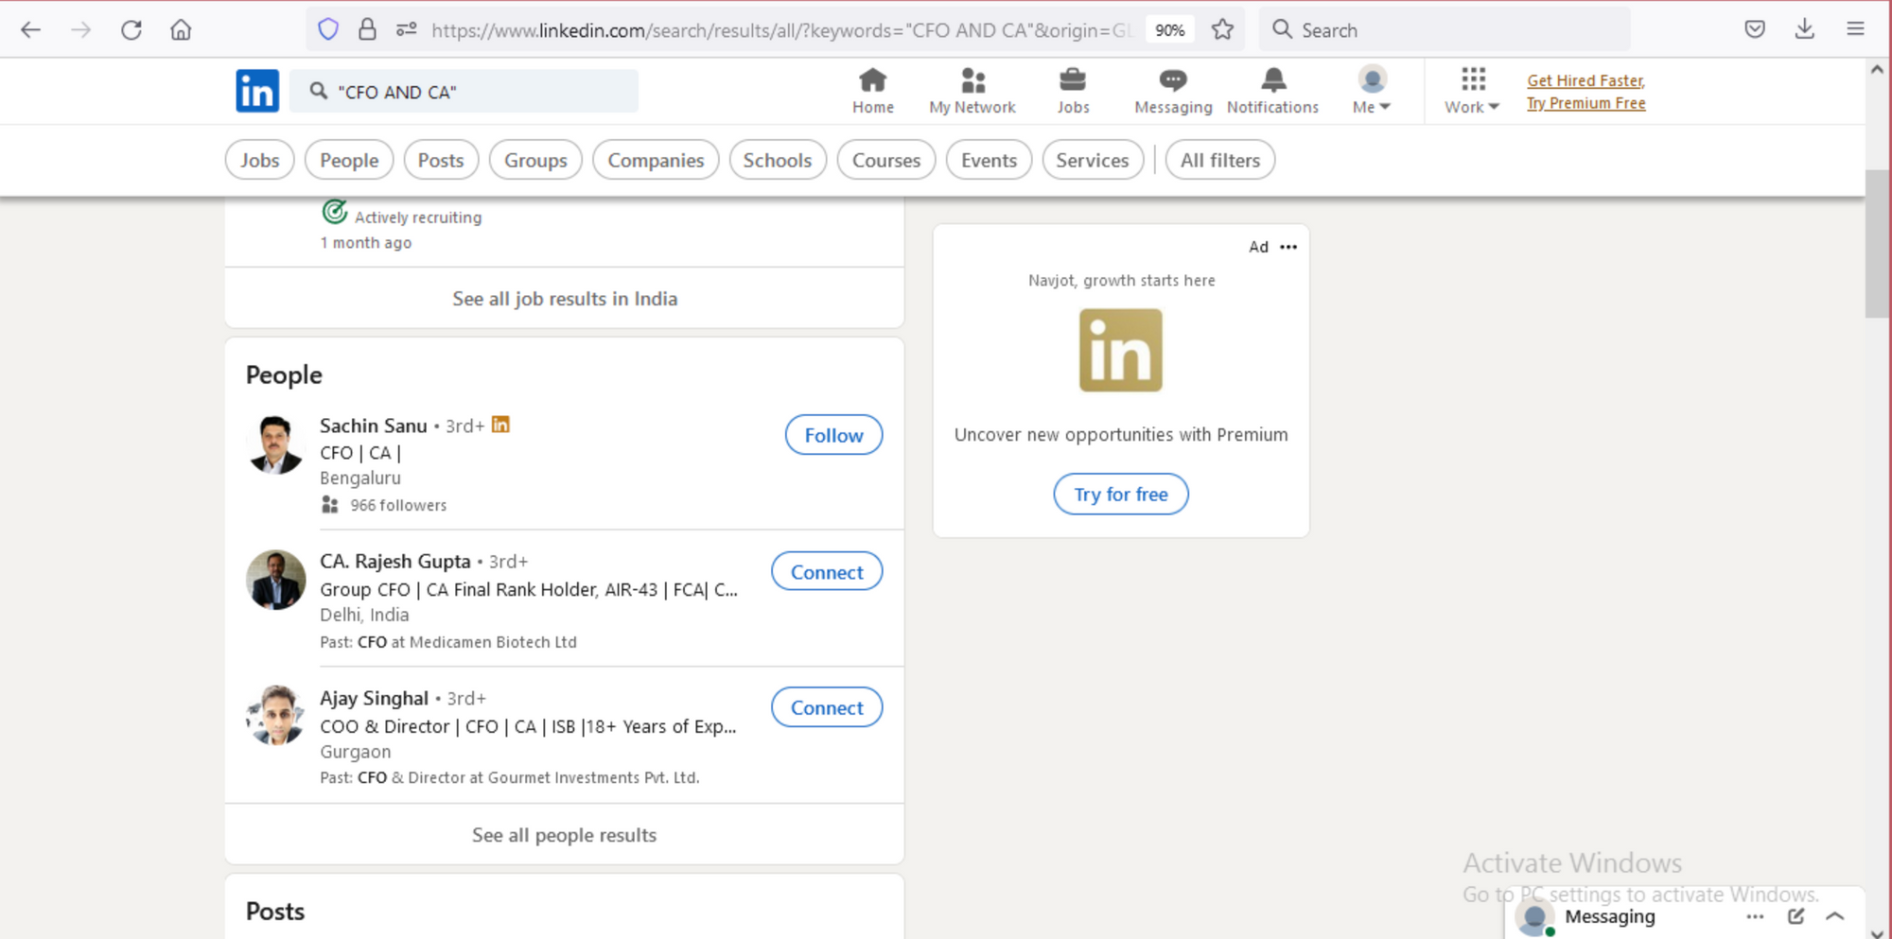*Source: LinkedIn*

### **Parenthesis ()**

This is how you **combo all the operators** we discussed so far.

For example, if you're looking for someone who has experience in either social media or content marketing, but you specifically need them to be a manager.



This is how you’ll be using parentheses to find those people:

(social media OR content marketing) AND manager

A few things to keep in mind about Boolean LinkedIn search:

* Use Caps Lock while typing AND, OR, NOT.
* Wildcard searches “*” are not supported with LinkedIn.
* Boolean search works in the Keyword field in LinkedIn.com or Recruiter, and in the Company, Title, and Keyword field in Sales Navigator.

Right, now that you know everything about how to get super specific with your searches, let’s try to understand

## **How to Search LinkedIn in Private Mode and Semi-Private Mode?**

**Do people get to know when you search for them on LinkedIn?** 🤔

No.

**Not unless you click on their profile** link and visit their profile.

But even if you do, there’s **a way to prevent** that from happening, after all, no one wants to give off that creepy stalker vibe.



If you want to [search for profiles on LinkedIn anonymously](https://www.linkedin.com/help/linkedin/answer/a567226/browsing-profiles-in-private-and-semi-private-mode?trk=lss-blog-who-viewed-your-profile?trk=lss-blog-who-viewed-your-profile), **use the Private Mode** feature**.**

Here’s how to **go incognito**:

1. Click your profile picture at the top.
2. Go to "Settings & Privacy".
3. Click "Visibility" on the left side.
4. Under "Profile viewing options", choose what you’d like:
   * **Your name and headline:** Full disclosure!
   * **Semi-private mode:** Share your job title and industry, but keep your name hidden.

If you’ve viewed someone using this semi-private mode they’ll know “A Hiring Manager at XYZ Company” viewed their profile.

* + **Private mode:** Remain totally anonymous.

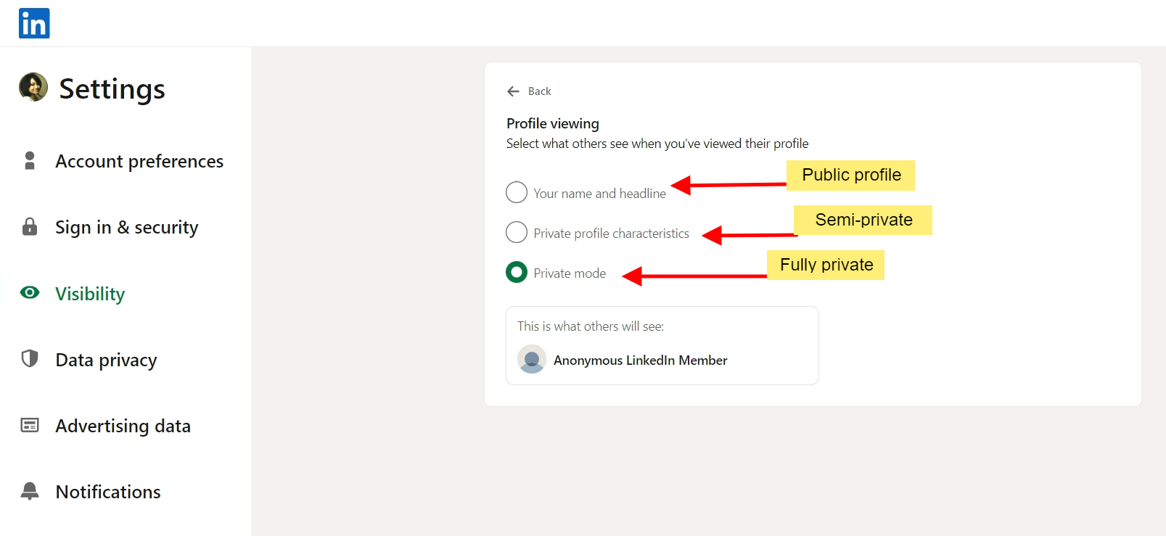

**When you’ve searched for someone on Private mode, you’ll appear as a “LinkedIn member”, when they check “Who viewed my Profile”.**

Privacy works both ways. If you’ve chosen not to let others see you’ve visited them, you too will be none the wiser when they visit your profile.

Unless [you have a LinkedIn Premium account](https://www.salesrobot.co/blogs/what-is-linkedin-premium). Then you can **browse in private mode and still see who viewed your profile.**

To keep things fair and respect the need for privacy, even LinkedIn Premium users will not know when someone visits their profile on private-mode.

I’ll give you a moment to let that sink in before moving on with

## **How to Search for LinkedIn Groups?**

[Getting yourself added to LinkedIn groups](https://www.linkedin.com/learning/linkedin-quick-tips-2022/join-linkedin-groups) where you’ll find your tribe could mean a lot for your business.

But the problem is how do you know which ones you need to be in?

Well FOMO, NOMO 😎

To search for groups, type keywords in the search bar at the top. For example, I typed “content marketing”.

Once you hit enter, look for “Groups” in the advanced search options. When you select “Groups” you’ll find loads of Groups where you’ll fit right in.

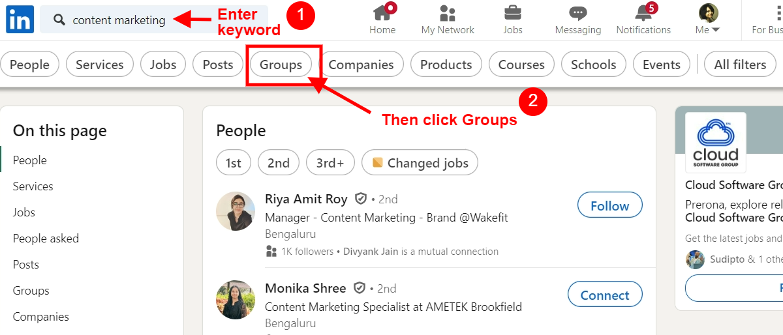

Wonderful, yes.

But [there’s a limit](https://www.linkedin.com/help/linkedin/answer/a544801).

**Number of groups a member can be part of** : 100

**Number of groups with pending request to join:** 20

**Character limit for group posts:** 3000

Moving on to

## **How to Search LinkedIn for Candidates?**

There are two main ways to search for candidates if you have a [LinkedIn Recruiter or a Recruiter Lite premium account:](https://www.salesrobot.co/blogs/linkedin-premium-pricing)

* **Global Search Bar**: At the top of the homepage.
* **Talent Pool Tab:** Within a specific project.

Here's how to search in both:

**Global Search Bar**:

There’s a **search bar at the top** to find people by job title, skills, or location. Use filters on the left to get more specific.

Don't forget, you can also continue past searches or find similar profiles to someone you already know.

**Talent Pool Tab**:

Head over to the **"Projects" tab**, find your project, and then click on "Talent Pool."

Here, you can use the search bar and filters on the left side to narrow down your search to just the people in your project.

Ok, now that we know how search works, it’s time to discuss

## **Is There a LinkedIn Monthly Limit for Profile Searches?**

If you have a **basic LinkedIn account** then your **search limit** will be **1000 profiles** (100 pages with 10 results each)

If you have a **premium profile** like Sales Navigator, your **search limit will be 2500 profiles** (100 pages with 25 results each)

Results beyond those numbers, won’t be accessible to you 😒

But hey, throwing a problem your way without giving an easy solution?

When have I done that? 😇

So here’s

## **How to Get Around LinkedIn Search Limit?**

[This secret LinkedIn InMail hack lets us send 800 InMails a month (without LinkedIn Premium)](https://www.youtube.com/watch?v=KJZk5-2fO3Y)

How to bypass LinkedIn search limits?

### **Search on Google**

This OG never lets you down.

Do a Boolean search on Google, for example,

site:linkedin.com/in/ ”CEO” AND USA AND Software

And hit enter.

You’ll get pages and pages of **results that exceed LinkedIn search limits.**

Then you can use a **third-party scraping tool** to **collect** these **LinkedIn profile URLs** and put them in a CSV.

We’ve even got a [blog to help you on this](https://www.salesrobot.co/blogs/linkedin-xray-search#how-to-scrape-linkedin-xray-search-results)!

### **LinkedIn Hashtag Search**

Go to the LinkedIn search bar and search for a hashtag relevant to your industry, for instance

#sales

Now you’ll **find a list of people who have added #sales to their posts**. Additionally, you can find the people who have engaged with these posts by checking out their likes and comments.

And then you can **scrape all these profile URLs** as well using a good scraping tool.

<https://www.youtube.com/watch?v=Go63PdDYCfg>

### **Create Multiple LinkedIn Profiles**

This solution has been staring at our faces all this while, but we never saw it, did we?

Make multiple profiles and search from each of them.

That being said, getting a list of leads is one thing, interacting with them is another.

So

## **How to Start an Outreach Campaign From LinkedIn Search?**

You have a **lead list.**

You have a **deadline.**

And you have a **very strict budget.**

Now what do you do?

Chill. Just start a multichannel outreach on [SalesRobot](https://www.salesrobot.co/).

Here’s how.

1. **Login** to [SalesRobot](https://app.salesrobot.co/register).
2. Click **I’m an advanced user**

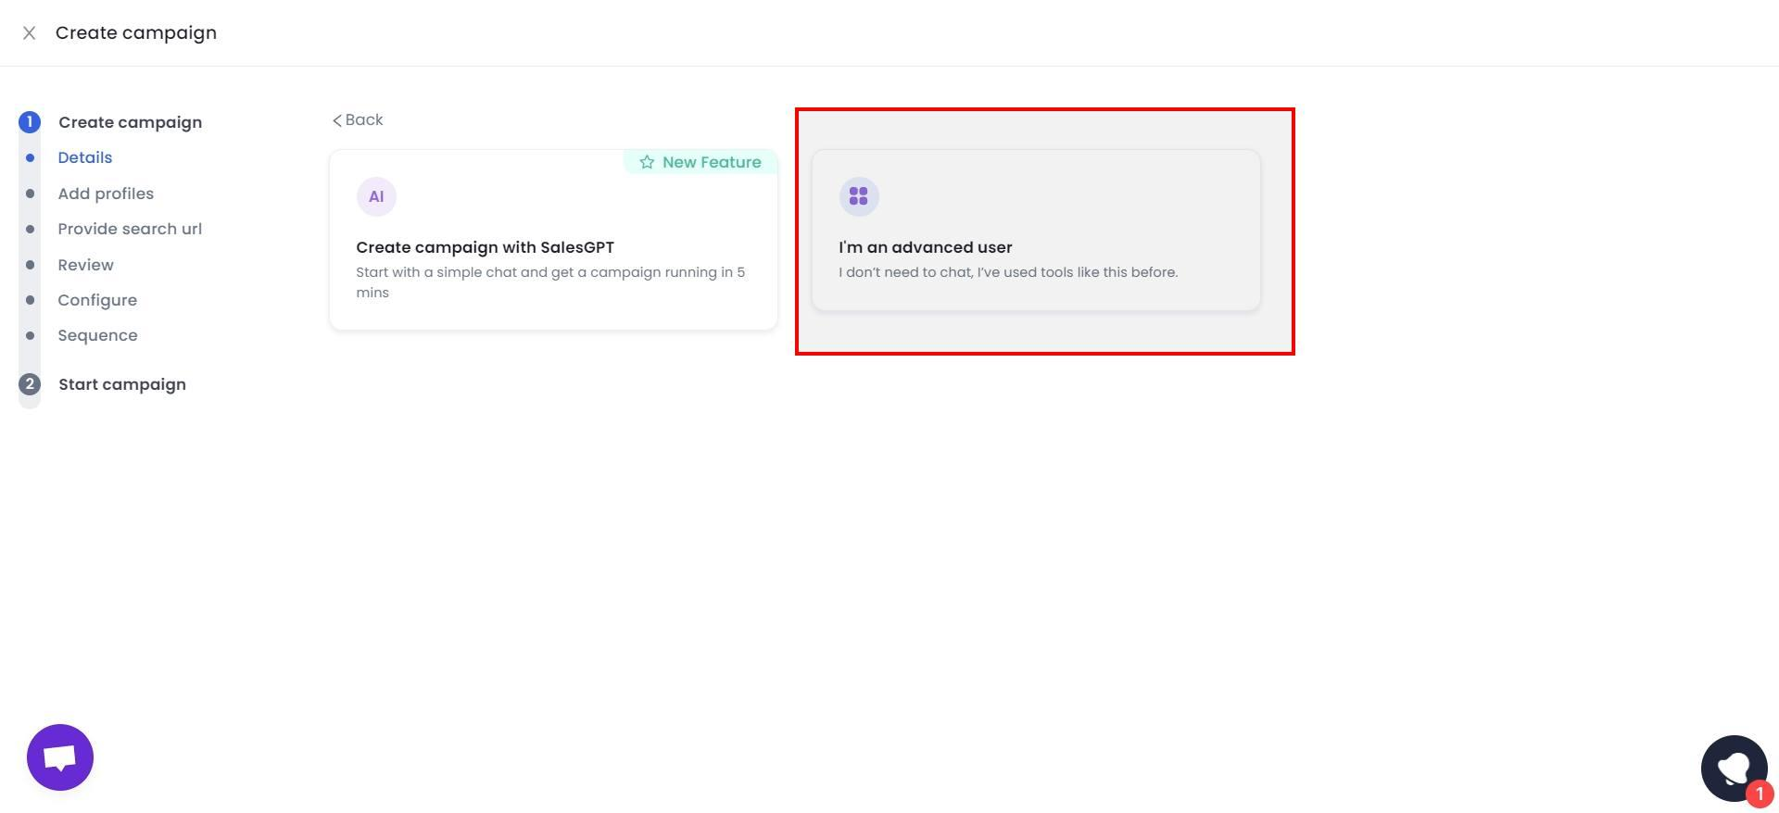

3. Name your campaign

4. **Select** “Import from CSV” if you already have a list of the URLs you want to contact.

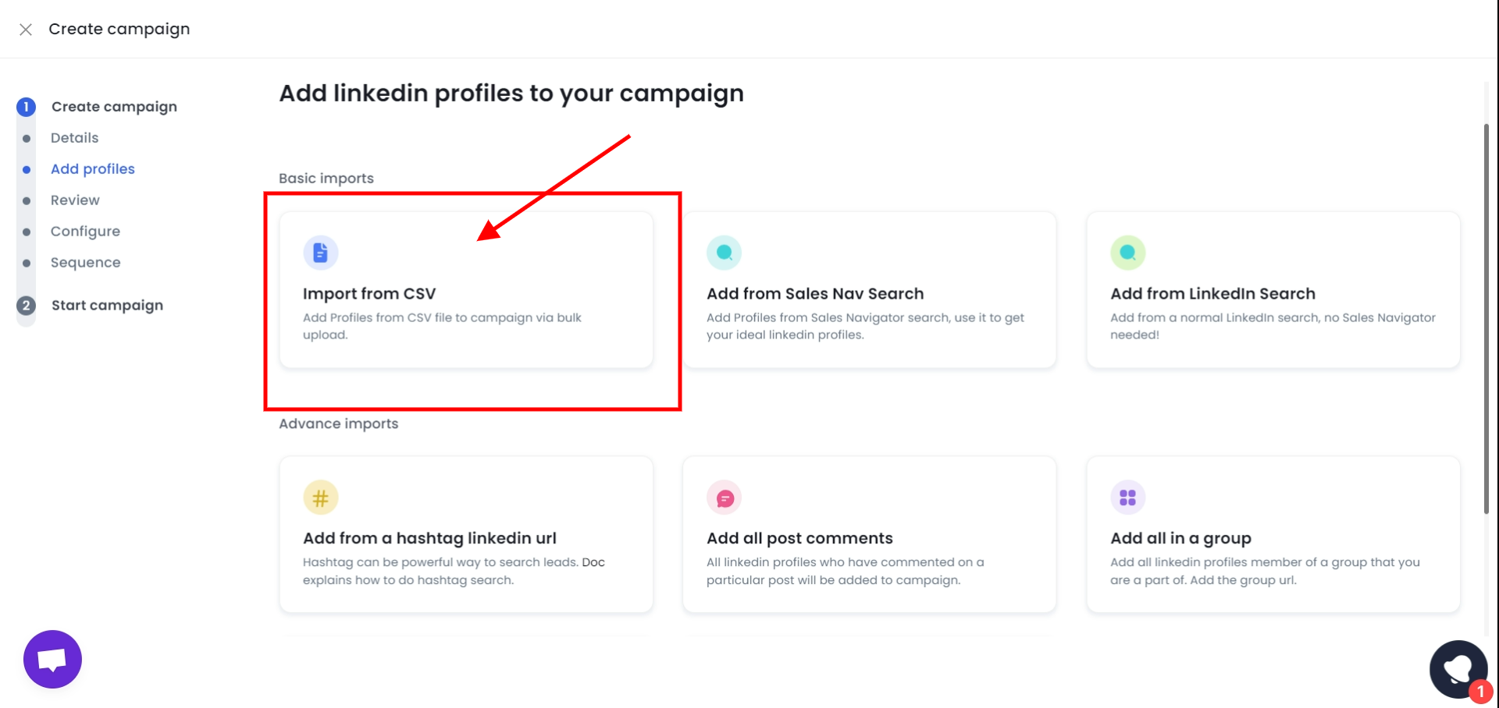

Or you can also use LinkedIn Search, Sales Nav Search, get it from post comments, groups. The world is your oyster really.

5. **Select** “Skip duplicates” to stop you from adding the same prospects you’ve already added on other campaigns.

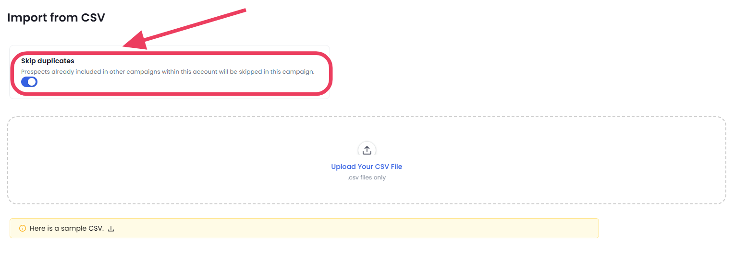

6**. Upload your CSV file** and click **Save Data**

7. Now click on **“Configure settings”**, and select **Enrich Data** if you need the prospect's email IDs and phone numbers.

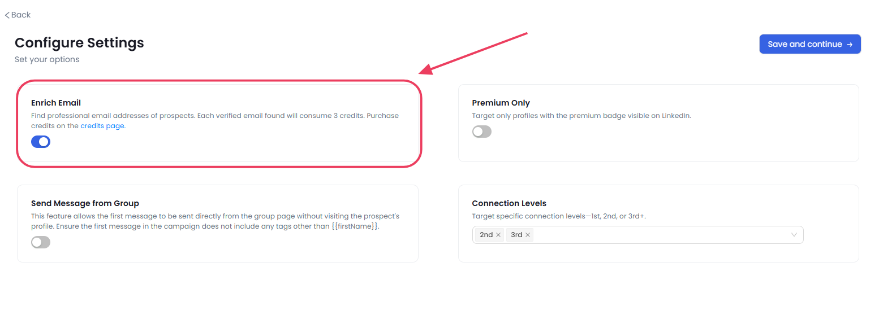

Then click **“Save and continue”**

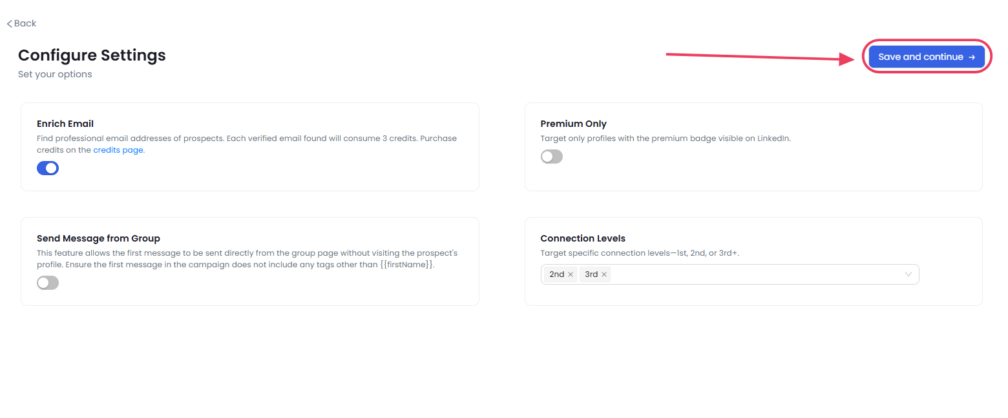

8. Pick **“Quick Start”** to start sending our prewritten messages,

**“From Template**” to let our AI add personalized touches to your messages, or

**“From Scratch”** if you want to write your own connection request messages.

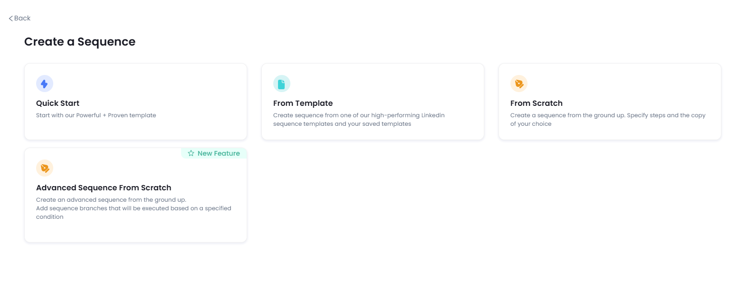

We’ve also got an **Advanced Sequence from Scratch** feature for most **customizability** and **custom conditional branching.**

[**SalesRobot**](https://www.salesrobot.co/) **lets you be as involved in your campaign as *you* choose to be.**

9. If you select **“From Scratch**” you can add sequences like sending connection requests, messages, emails, follow-ups…the works.



10. Once you’re satisfied with the sequences just select **“Save”** and click **“Start campaign”.**

That’s it.

Now sit back and watch the sunset 🌇while [SalesRobot](https://www.salesrobot.co/) visits all those profiles and warms them up for you.

Need some more hand holding?

Sure, this video explains everything in detail:

[Sales Robot | How To Create A Connection Request Campaign using CSV File](https://www.youtube.com/watch?v=uAGpSB7b9CU)

[Create](https://www.youtube.com/watch?v=uAGpSB7b9CU)

The **SalesRobot Readability Score** tells you how likely your prospects are to send you a reply.

It can calculate this based on the key metrics that make a really good outreach message.

## **Conclusion**

So, there you go.

🙌You’ve learned how to search for prospects on LinkedIn using various proven methods.

🙌Understood what are LinkedIn search limits.

🙌Discovered how to overcome them like a pro, and most importantly

🙌You now know how to plan an outreach campaign to turn those leads into your dream customer using SalesRobot.

So if we’ve piqued your curiosity, [**try our features risk-free**](https://app.salesrobot.co/register) **with a 14-day free trial.**

**No credit card or phone number needed** — just your email, and you're good to go!

✌️